**1.Introduction**

* 1. **Overview**

Carbon dioxide (CO2) is a colourless, odourless and non-poisonous gas formed by combustion of carbon and in the respiration of living organisms and is considered a [greenhouse gas](https://ec.europa.eu/eurostat/statistics-explained/index.php?title=Glossary:Greenhouse_gas_(GHG)). Emissions means the release of greenhouse gases and/or their precursors into the atmosphere over a specified area and period of time. **Carbon dioxide emissions** or **CO2 emissions** are emissions stemming from the burning of [fossil fuels](https://ec.europa.eu/eurostat/statistics-explained/index.php?title=Glossary:Fossil_fuel) and the manufacture of cement; they include carbon dioxide produced during consumption of solid, liquid, and gas fuels as well as gas flaring.

* 1. **Purpose**

**CO2 used is not the same as CO2 avoided.** CO2 use does not necessarily reduce emissions and quantifying climate benefits is complex, requiring a comprehensive life-cycle assessment as well as understanding of market dynamics. CO2 use can provide climate benefits where the application is scalable, uses low-carbon energy, and displaces a product with higher life-cycle emissions. Longer term, in a net-zero CO2 emission energy system, the CO2 would have to be sourced from biomass or the air to achieve climate benefits. CO2-derived products that involve permanent carbon retention, such as building materials, can offer larger emissions reductions than products that ultimately release CO2 to the atmosphere, such as fuels and chemicals.

**Improved understanding and quantification of CO2 use applications and their emission reduction potential is required.**To inform future policy and investment decisions, there is a need for robust life-cycle analyses based on clear methodological guidelines and transparent datasets. In recent years, several expert groups have started to develop such guidelines; however, it remains challenging due to the early stage of development of many CO2 use technologies.

**CO2 use is a complement, not an alternative, to CO2 storage for large-scale emissions reductions.** CO2use is not expected to deliver emissions reductions on the same scale as carbon capture and storage (CCS), but can play a role in meeting climate goals as part of an “all technologies” approach. In International Energy Agency (IEA) scenario analysis with limited deployment of CO2storage, CO2use within the energy system increases (including for the production of methanol and synthetic hydrocarbon fuels) but delivers less than 13% of the emissions reductions that would otherwise be provided from CO2storage. The potential for negative emissions from CO2use is also very limited.

**2. Problem Definition & Design Thinking**

**2.1 Empathy Map**

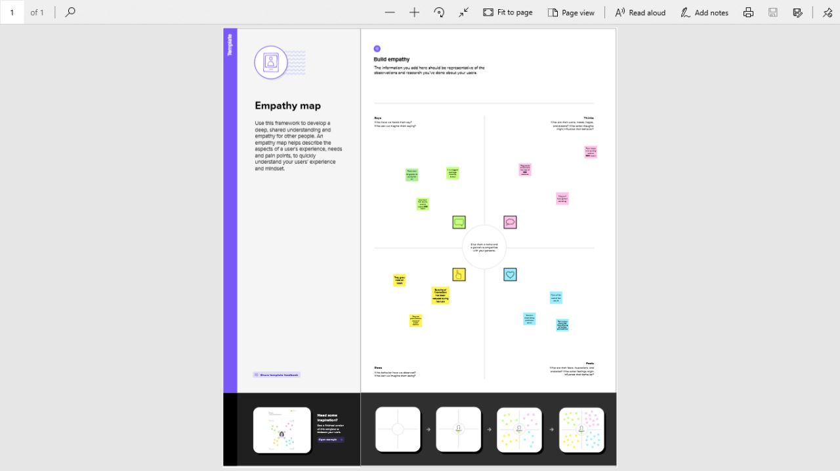

**2.2 Ideation & Brainstorming Map**

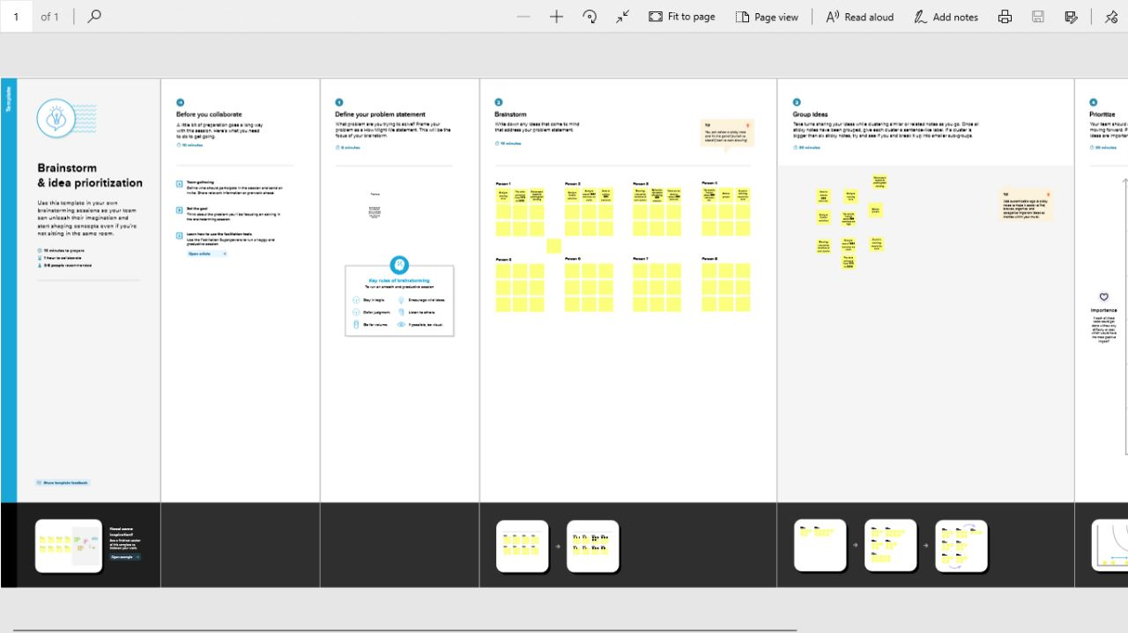

**3. Results**

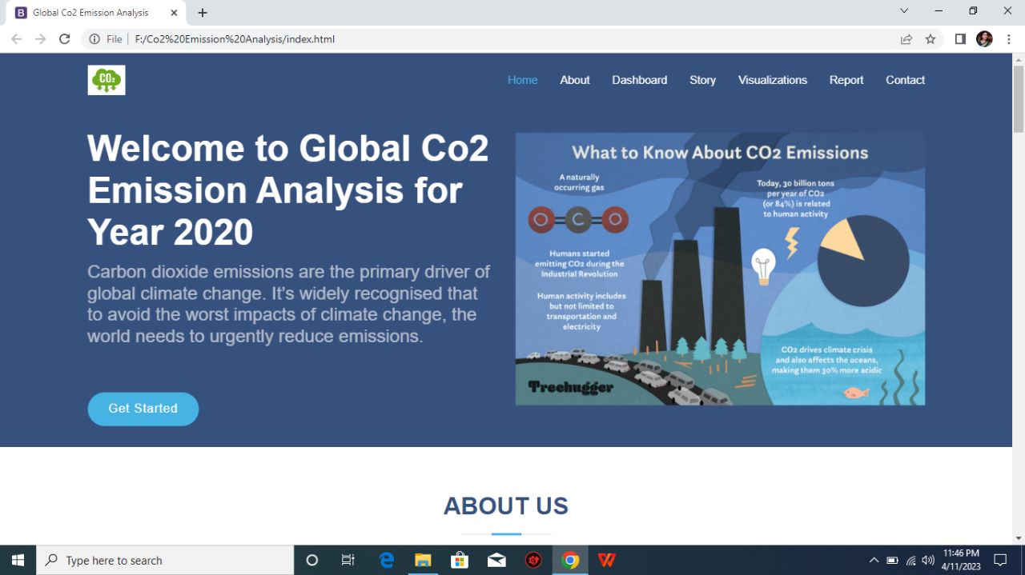

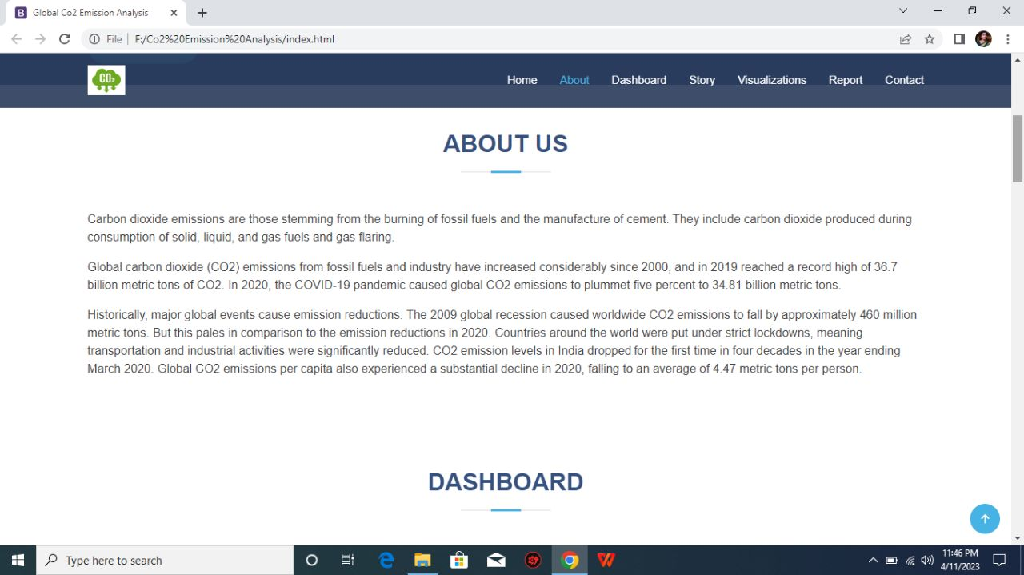

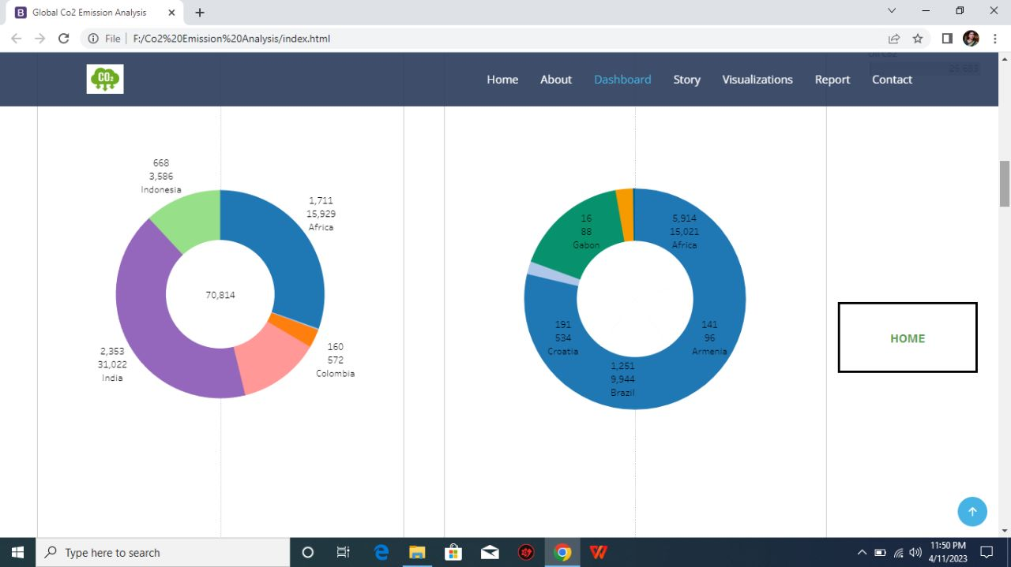

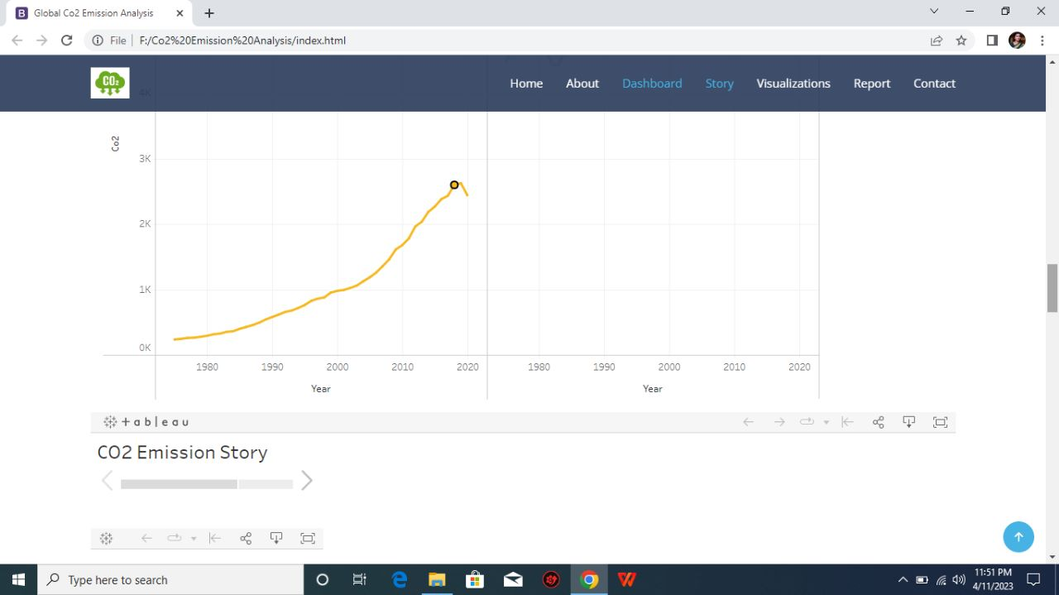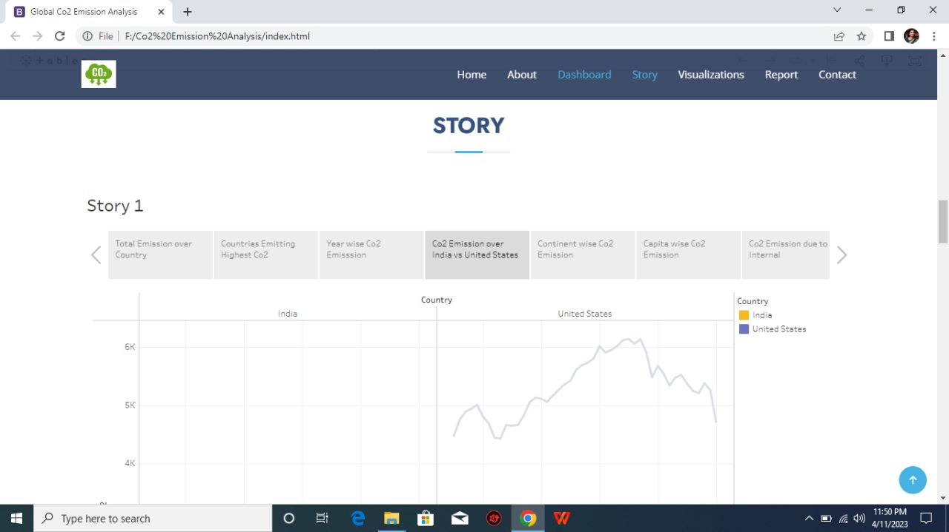

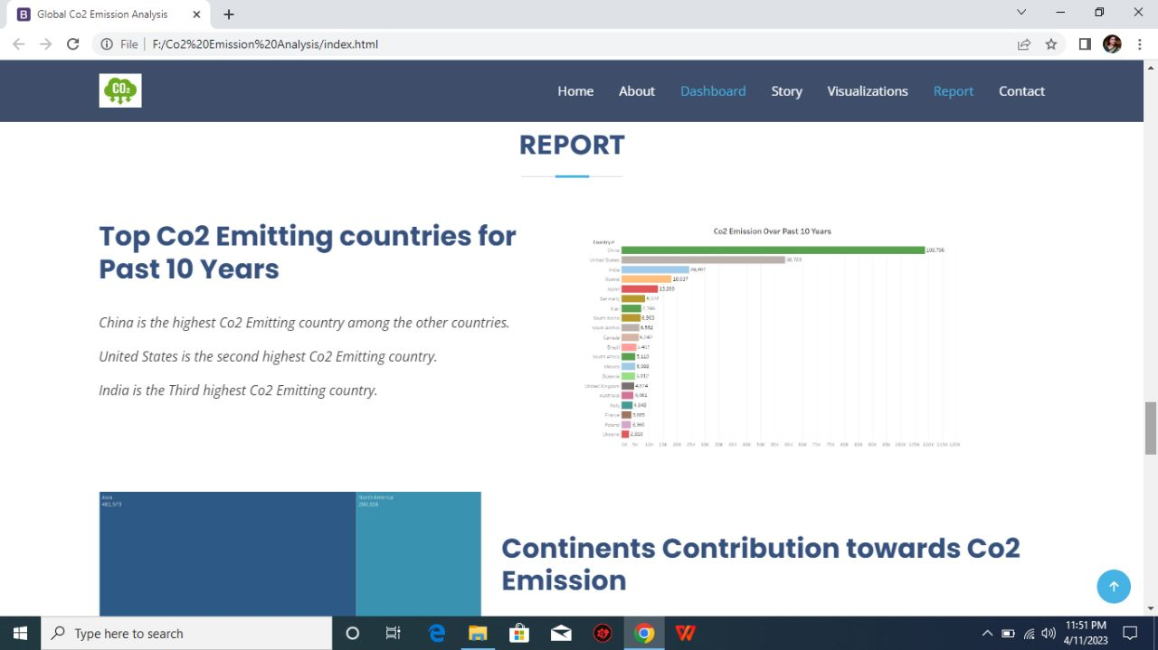

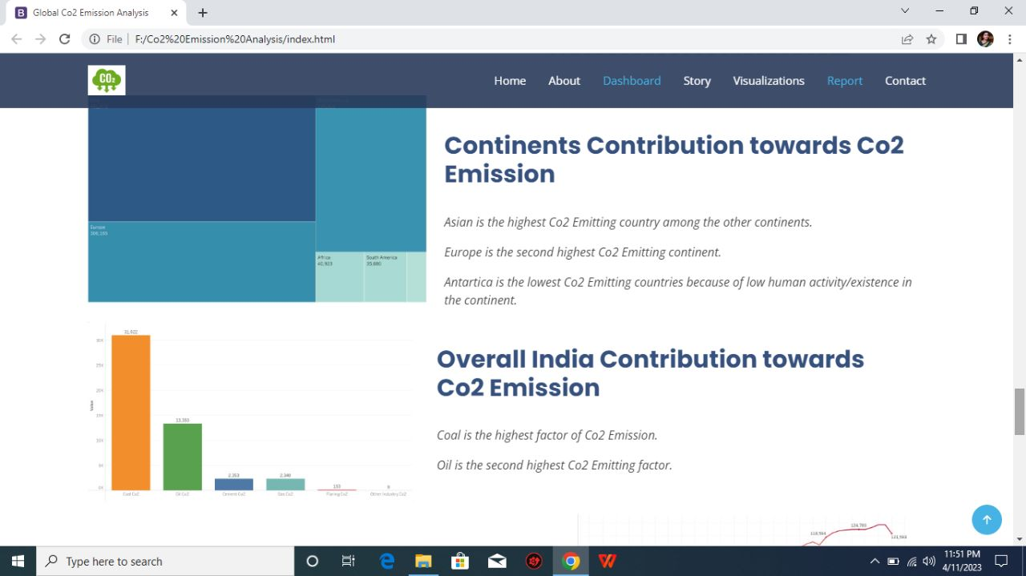

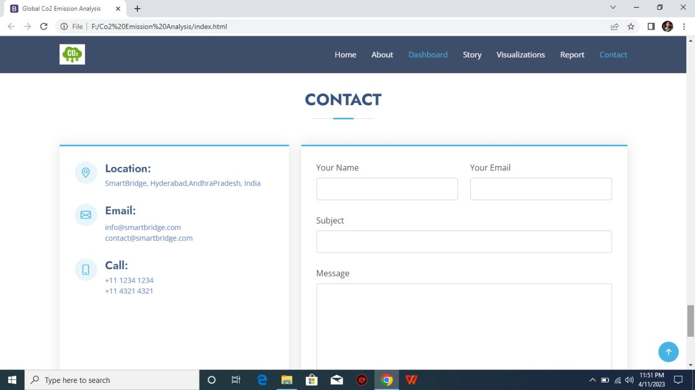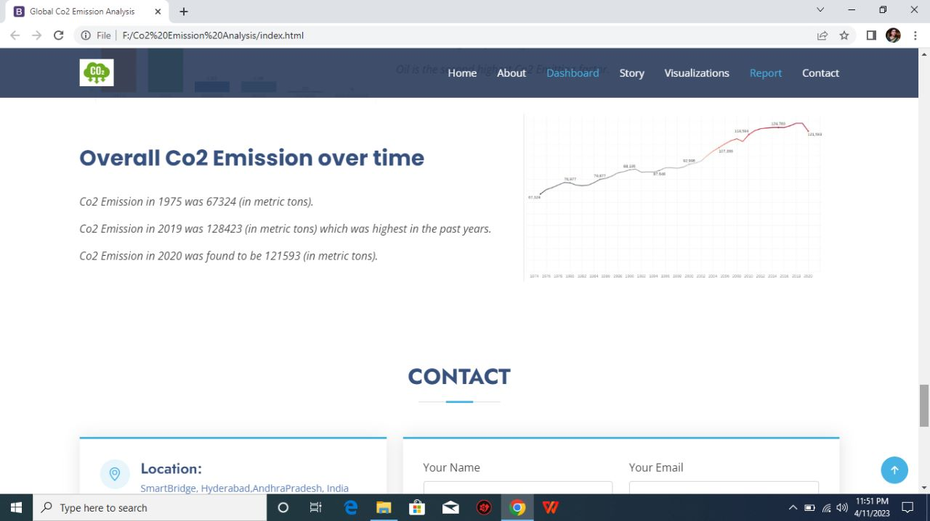

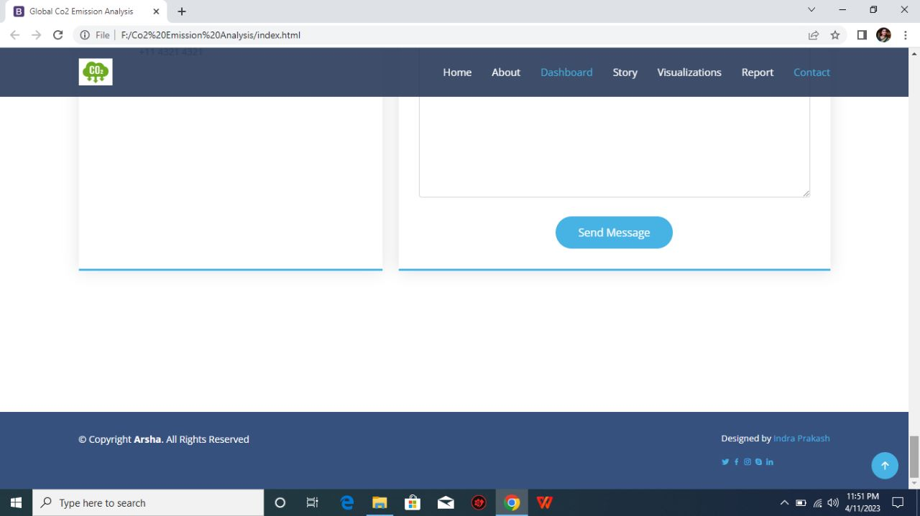

**4. Advantages & Disadvantages**

**4.1 Advantages**

Carbon capture and storage is one of the most efficient methods of extracting carbon emissions permanently from the environment.

The numerous advantages of CCS include economic, social, and environmental, and a massive impact on a global and local scale.

Carbon capture can increase the power generated with carbon dioxide-based steam cycles. In this process, carbon dioxide is pressured through a supercritical fluid, which could transfer heat more effectively and require less energy to compress steam.

Geologically stored carbon dioxide might be utilized to retrieve geothermal heat from the area injected which results in the generation of sustainable geothermal energy.

Carbon dioxide captured with carbon capture can also be utilized in the manufacturing of polymers and chemicals such as polyurethanes.

The captured carbon dioxide is incorporated into concrete to reinforce it and increase the durability of the infrastructure. The carbon capture operations create employment for skilled engineers and technicians who need to operate them.

**4.2 Disadvantages**

Carbon capture reduces the carbon released in the atmosphere and therefore, it is recognized as one of the solutions to help address climate change and global warming. Despite this, carbon capture and storage (CCS) does not come without some disadvantages.

The methods and CCS technologies that are necessary for carbon capture have some cost implications attached to them. Therefore, it can be very costly for power plants to generate electricity through fossil fuels. There are several concerns with respect to the safety of the storage of carbon dioxide in huge volumes at a single location due to the possibility of leakages, which can lead to environmental contamination if not handled correctly.

The possibility of leakages could also be a result of natural disasters such as earthquakes or can be a result of human-induced incidents such as damage as a result of wars that can damage underground storage reservoirs.

Many critics have questioned the cost efficiency of basalt formation storage. For this option, 25 tons of water will be required for each ton of carbon dioxide to be buried. There is a possibility that volcanic rock microbes can also digest the carbonates and hence produce methane gas which can be another problem.

Another disadvantage of carbon capture storage is that it is not adequate to successfully deal with climate change. The emissions that come from heat and power generation as a result of using fossil fuels only account for about 25% of the total greenhouse gas (GHG) emission, while 60% of

all greenhouse gas emissions come from transportation, agriculture, and other related industrial activities. These emissions are currently not being captured by carbon capture and storage

**5. Application**

***Multi-Industry Uses for Carbon Dioxide (CO2):***

Carbon dioxide in solid and in liquid form is used for refrigeration and cooling.  It is used as an inert gas in chemical processes, in the storage of carbon powder and in fire extinguishers.

***Metals Industry:***

Carbon dioxide is used in the manufacture of casting molds to enhance their hardness.

***Manufacturing and Construction Uses:***

Carbon dioxide is used on a large scale as a shield gas in MIG/MAG welding, where the gas protects the weld puddle against oxidation by the surrounding air.  A mixture of argon and carbon dioxide is commonly used today to achieve a higher welding rate and reduce the need for post weld treatment.

Dry ice pellets are used to replace sandblasting when removing paint from surfaces.  It aids in reducing the cost of disposal and cleanup.

***Chemicals, Pharmaceuticals and Petroleum Industry Uses:***

Large quantities are used as a raw material in the chemical process industry, especially for methanol and urea production.

Carbon dioxide is used in oil wells for oil extraction and to maintain pressure within a formation.. When CO2 is pumped into an oil well, it is partially dissolved into the oil, rendering it less viscous, allowing the oil to be extracted more easily from the bedrock.  Considerably more oil can be extracted from through this process.

***Rubber and Plastics Industry Uses:***

Flash is removed from rubber objects by tumbling them with crushed dry ice in a rotating drum.

**6. Conclusion**

The economics of CO2 utilization are discussed from a critical perspective, with a concise analysis of the state-of-the-art of economics in power-to-X (methanol, methane). The main elements of the analysis of the economics are commented to provide guidelines on how to interpret the techno-economic results in the area of CO2 utilization. It remarks the need of a careful analysis of the specific context, and of the limits of the evaluation, in order to go beyond the just use of the results without a proper analysis of how the data support the conclusions, their limits and applicability. Case examples discussed in a more detail regard the CO2 to methanol or methane conversion, from the perspective of highlighting possible issues or limits rather than to indicate which results are more valuable, which is out of the scope of this contribution.

**7. Future Scope**

Emissions from natural gas decreased by 1.6% or 118 Mt in 2022, as an already tight gas supply was exacerbated by Russia’s invasion of Ukraine and the widespread trade disruptions that followed.

Emissions reductions were particularly pronounced in Europe, where they fell by 13.5%, with the strongest year-on-year reductions coming in the last months of the year. European gas prices reached record highs in 2022 following a sharp decline in Russian gas flows. However, a mild start to winter helped reduce household heating demand. In the Asia Pacific, LNG spot prices also spiked, and natural gas emissions declined by 1.8%, the largest year-on-year decline ever seen in the region. By contrast, natural gas demand remained robust in the United States and Canada, where emissions from gas increased by 5.8%.

Coal emissions grew 243 Mt to a new all-time high of almost 15.5 Gt. This 1.6% increase was faster than the 0.4% annual average growth over the past decade.

**8. Appendix**

<!DOCTYPE html>

<html lang="en">

<head>

<meta charset="utf-8">

<meta content="width=device-width, initial-scale=1.0" name="viewport">

<title>Global Co2 Emission Analysis</title>

<meta content="" name="description">

<meta content="" name="keywords">

<!-- Favicons -->

<link href="assets/img/favicon.png" rel="icon">

<link href="assets/img/apple-touch-icon.png" rel="apple-touch-icon">

<!-- Google Fonts -->

<link href="https://fonts.googleapis.com/css?family=Open+Sans:300,300i,400,400i,600,600i,700,700i|Jost:300,300i,400,400i,500,500i,600,600i,700,700i|Poppins:300,300i,400,400i,500,500i,600,600i,700,700i" rel="stylesheet">

<!-- Vendor CSS Files -->

<link href="assets/vendor/aos/aos.css" rel="stylesheet">

<link href="assets/vendor/bootstrap/css/bootstrap.min.css" rel="stylesheet">

<link href="assets/vendor/bootstrap-icons/bootstrap-icons.css" rel="stylesheet">

<link href="assets/vendor/boxicons/css/boxicons.min.css" rel="stylesheet">

<link href="assets/vendor/glightbox/css/glightbox.min.css" rel="stylesheet">

<link href="assets/vendor/remixicon/remixicon.css" rel="stylesheet">

<link href="assets/vendor/swiper/swiper-bundle.min.css" rel="stylesheet">

<!-- Template Main CSS File -->

<link href="assets/css/style.css" rel="stylesheet">

<!-- =======================================================

* Template Name: Arsha - v4.10.0

* Template URL: https://bootstrapmade.com/arsha-free-bootstrap-html-template-corporate/

* Author: BootstrapMade.com

* License: https://bootstrapmade.com/license/

======================================================== -->

</head>

<body>

<!-- ======= Header ======= -->

<header id="header" class="fixed-top ">

<div class="container d-flex align-items-center justify-content-between">

<h1 class="logo"><img src="https://media.istockphoto.com/id/1323550608/vector/co2-reduction-cloud-eco-vector-icon.jpg?s=612x612&w=0&k=20&c=jO3OZfYAg9gB8TWvzH8BR64Lq3pFrfHcOvxpSgB-cjA="> </h1>

<!-- Uncomment below if you prefer to use an image logo -->

<!-- <a href="index.html" class="logo me-auto"><img src="assets/img/logo.png" alt="" class="img-fluid"></a>-->

<nav id="navbar" class="navbar">

<ul>

<li><a class="nav-link scrollto active" href="#hero">Home</a></li>

<li><a class="nav-link scrollto" href="#about">About</a></li>

<li><a class="nav-link scrollto" href="#dash">Dashboard</a></li>

<li><a class="nav-link scrollto" href="#services">Story</a></li>

<li><a class="nav-link scrollto" href="#portfolio">Visualizations</a></li>

<li><a class="nav-link scrollto" href="#report">Report</a></li>

<li><a class="nav-link scrollto" href="#contact">Contact</a></li>

</ul>

<i class="bi bi-list mobile-nav-toggle"></i>

</nav>

<!-- .navbar -->

</div>

</header>

<!-- End Header -->

<!-- ======= Hero Section ======= -->

<section id="hero" class="d-flex align-items-center">

<div class="container">

<div class="row">

<div class="col-lg-6 d-flex flex-column justify-content-center pt-4 pt-lg-0 order-2 order-lg-1" data-aos="fade-up" data-aos-delay="200">

<h1>Welcome to Global Co2 Emission Analysis for Year 2020</h1>

<h2>Carbon dioxide emissions are the primary driver of global climate change. Itâ€™s widely recognised that to avoid the worst impacts of climate change, the world needs to urgently reduce emissions.</h2>

<div class="d-flex justify-content-center justify-content-lg-start">

<a href="#about" class="btn-get-started scrollto">Get Started</a>

<a href="https://www.youtube.com/watch?v=jDDaplaOz7Q" class="glightbox btn-watch-video"></a>

</div>

</div>

<div class="col-lg-6 order-1 order-lg-2 hero-img" data-aos="zoom-in" data-aos-delay="200">

<img src="https://www.treehugger.com/thmb/LbdMV9gbfA1S7Y3SB0XhlSl4EFw=/1500x0/filters:no_upscale():max_bytes(150000):strip_icc()/co-why-is-carbon-dioxide-bad-4864246_V2-4ea7c0936b5a4cd3b8d4f2b41ec02f63.png" class="img-fluid animated" alt="">

</div>

</div>

</div>

</section>

<!-- End Hero -->

<main id="main">

<!-- ======= Clients Section ======= -->

<!-- End Cliens Section -->

<!-- ======= About Us Section ======= -->

<section id="about" class="about">

<div class="container">

<div class="section-title">

<h2>About Us</h2>

</div>

<div class="row content">

<div class="col-lg-12">

<p>

Carbon dioxide emissions are those stemming from the burning of fossil fuels and the manufacture of cement. They include carbon dioxide produced during consumption of solid, liquid, and gas fuels and gas flaring.

</p>

<p>

Global carbon dioxide (CO2) emissions from fossil fuels and industry have increased considerably since 2000, and in 2019 reached a record high of 36.7 billion metric tons of CO2. In 2020, the COVID-19 pandemic caused global CO2 emissions to plummet five

percent to 34.81 billion metric tons.</p>

<p> Historically, major global events cause emission reductions. The 2009 global recession caused worldwide CO2 emissions to fall by approximately 460 million metric tons. But this pales in comparison to the emission reductions in

2020. Countries around the world were put under strict lockdowns, meaning transportation and industrial activities were significantly reduced. CO2 emission levels in India droppedâ€¯for the first time in four decades in the year

ending March 2020. Global CO2 emissions per capita also experienced a substantial decline in 2020, falling to an average of 4.47 metric tons per person.</p>

</div>

</div>

</div>

</section>

<!-- End About Us Section -->

<!-- ======= Why Us Section ======= -->

<section id="dash" class="">

<div class="container-fluid" data-aos="fade-up">

<div class="section-title">

<h2>Dashboard</h2>

</div>

<div class='tableauPlaceholder' id='viz1681228121809' style='position: relative'><noscript><a href='#'><img alt='dash5 ' src='https:&#47;&#47;public.tableau.com&#47;static&#47;images&#47;Bo&#47;Book1_16802767397480&#47;dash5&#47;1_rss.png' style='border: none' /></a></noscript><object class='tableauViz' style='display:none;'><param name='host_url' value='https%3A%2F%2Fpublic.tableau.com%2F' /> <param name='embed_code_version' value='3' /> <param name='site_root' value='' /><param name='name' value='Book1_16802767397480&#47;dash5' /><param name='tabs' value='no' /><param name='toolbar' value='yes' /><param name='static_image' value='https:&#47;&#47;public.tableau.com&#47;static&#47;images&#47;Bo&#47;Book1_16802767397480&#47;dash5&#47;1.png' /> <param name='animate_transition' value='yes' /><param name='display_static_image' value='yes' /><param name='display_spinner' value='yes' /><param name='display_overlay' value='yes' /><param name='display_count' value='yes' /><param name='language' value='en-US' /><param name='filter' value='publish=yes' /></object></div> <script type='text/javascript'> var divElement = document.getElementById('viz1681228121809'); var vizElement = divElement.getElementsByTagName('object')[0]; if ( divElement.offsetWidth > 800 ) { vizElement.style.width='100%';vizElement.style.height=(divElement.offsetWidth*0.75)+'px';} else if ( divElement.offsetWidth > 500 ) { vizElement.style.width='100%';vizElement.style.height=(divElement.offsetWidth*0.75)+'px';} else { vizElement.style.width='100%';vizElement.style.height='877px';} var scriptElement = document.createElement('script'); scriptElement.src = 'https://public.tableau.com/javascripts/api/viz_v1.js'; vizElement.parentNode.insertBefore(scriptElement, vizElement); </script>

<param name='tabs' value='no' /><param name='toolbar' value='yes' />

<param name='static_image' value='https:&#47;&#47;public.tableau.com&#47;static&#47;images&#47;Co&#47;Co2dash&#47;Dashboard1&#47;1.png' />

<param name='animate_transition' value='yes' />

<param name='display_static_image' value='yes' />

<param name='toolbar' value='no' />

<param name='display_spinner' value='yes' />

<param name='display_overlay' value='yes' />

<param name='display_count' value='yes' />

<param name='language' value='en-US' />

<param name='showShareOptions' value='false' />

</object>

</div>

<script type='text/javascript'>

var divElement = document.getElementById('viz1672205035633');

var vizElement = divElement.getElementsByTagName('object')[0];

if (divElement.offsetWidth > 800) {

vizElement.style.width = '100%';

vizElement.style.height = (divElement.offsetWidth * 0.75) + 'px';

} else if (divElement.offsetWidth > 500) {

vizElement.style.width = '90%';

vizElement.style.height = (divElement.offsetWidth * 0.75) + 'px';

} else {

vizElement.style.width = '100%';

vizElement.style.height = '1477px';

}

var scriptElement = document.createElement('script');

scriptElement.src = 'https://public.tableau.com/javascripts/api/viz_v1.js';

vizElement.parentNode.insertBefore(scriptElement, vizElement);

</script>

</div>

<!-- End Why Us Section -->

<section id="services" class="services">

<div class="container" data-aos="fade-up">

<div class="section-title">

<h2>Story</h2>

</div>

<div class='tableauPlaceholder' id='viz1681228395840' style='position: relative'><noscript><a href='#'><img alt='Story 1 ' src='https:&#47;&#47;public.tableau.com&#47;static&#47;images&#47;Bo&#47;Book1_16802767397480&#47;Story1&#47;1_rss.png' style='border: none' /></a></noscript><object class='tableauViz' style='display:none;'><param name='host_url' value='https%3A%2F%2Fpublic.tableau.com%2F' /> <param name='embed_code_version' value='3' /> <param name='site_root' value='' /><param name='name' value='Book1_16802767397480&#47;Story1' /><param name='tabs' value='no' /><param name='toolbar' value='yes' /><param name='static_image' value='https:&#47;&#47;public.tableau.com&#47;static&#47;images&#47;Bo&#47;Book1_16802767397480&#47;Story1&#47;1.png' /> <param name='animate_transition' value='yes' /><param name='display_static_image' value='yes' /><param name='display_spinner' value='yes' /><param name='display_overlay' value='yes' /><param name='display_count' value='yes' /><param name='language' value='en-US' /></object></div> <script type='text/javascript'> var divElement = document.getElementById('viz1681228395840'); var vizElement = divElement.getElementsByTagName('object')[0]; vizElement.style.width='100%';vizElement.style.height=(divElement.offsetWidth*0.75)+'px'; var scriptElement = document.createElement('script'); scriptElement.src = 'https://public.tableau.com/javascripts/api/viz_v1.js'; vizElement.parentNode.insertBefore(scriptElement, vizElement); </script>

<noscript><a href='#'><img alt='CO2 Emission Story ' src='https:&#47;&#47;public.tableau.com&#47;static&#47;images&#47;G4&#47;G4Q8N94F4&#47;1_rss.png' style='border: none' /></a>

</noscript><object class='tableauViz' style='display:none;'>

<param name='host_url' value='https%3A%2F%2Fpublic.tableau.com%2F' />

<param name='embed_code_version' value='3' /> <param name='path' value='shared&#47;G4Q8N94F4' />

<param name='toolbar' value='yes' />

<param name='static_image' value='https:&#47;&#47;public.tableau.com&#47;static&#47;images&#47;G4&#47;G4Q8N94F4&#47;1.png' />

<param name='animate_transition' value='yes' />

<param name='display_static_image' value='yes' />

<param name='display_spinner' value='yes' />

<param name='display_overlay' value='yes' />

<param name='display_count' value='yes' />

<param name='language' value='en-US' /></object></div>

<script type='text/javascript'>

var divElement = document.getElementById('viz1672206123585');

var vizElement = divElement.getElementsByTagName('object')[0];

vizElement.style.width = '100%';

vizElement.style.height = (divElement.offsetWidth * 0.75) + 'px';

var scriptElement = document.createElement('script');

scriptElement.src = 'https://public.tableau.com/javascripts/api/viz_v1.js';

vizElement.parentNode.insertBefore(scriptElement, vizElement);

</script>

</div>

</section>

<!-- ======= Skills Section ======= -->

<!-- End Skills Section -->

<!-- End Services Section -->

<!-- ======= Cta Section ======= -->

<!-- End Cta Section -->

<!-- ======= Portfolio Section ======= -->

<section id="portfolio" class="portfolio">

<div class="container" data-aos="fade-up">

<div class="section-title">

<h2>Visualizations</h2>

</div>

<div class="row portfolio-container">

<div class="col-lg-4 col-md-6 portfolio-item filter-web">

<div class="portfolio-wrap">

<img src="assets/img/img2.jpg" class="img-fluid" alt="">

<div class="portfolio-info">

<h4>Image 1 </h4>

<div class="portfolio-links">

<a href="assets/img/portfolio/p1.jpg" data-gallery="portfolioGallery" class="portfolio-lightbox" title="Web 3"><i class="bx bx-plus"></i></a>

</div>

</div>

</div>

</div>

<div class="col-lg-4 col-md-6 portfolio-item filter-web">

<div class="portfolio-wrap">

<img src="assets/img/img3.jpg" class="img-fluid" alt="">

<div class="portfolio-info">

<h4>Image 2 </h4>

<div class="portfolio-links">

<a href="assets/img/portfolio/p1.jpg" data-gallery="portfolioGallery" class="portfolio-lightbox" title="Web 3"><i class="bx bx-plus"></i></a>

</div>

</div>

</div>

</div>

<div class="col-lg-4 col-md-6 portfolio-item filter-web">

<div class="portfolio-wrap">

<img src="assets/img/img4.jpg" class="img-fluid" alt="">

<div class="portfolio-info">

<h4>Image 3 </h4>

<div class="portfolio-links">

<a href="assets/img/portfolio/p1.jpg" data-gallery="portfolioGallery" class="portfolio-lightbox" title="Web 3"><i class="bx bx-plus"></i></a>

</div>

</div>

</div>

</div>

<div class="col-lg-4 col-md-6 portfolio-item filter-web">

<div class="portfolio-wrap">

<img src="assets/img/img5.jpg" class="img-fluid" alt="">

<div class="portfolio-info">

<h4>Image 5</h4>

<div class="portfolio-links">

<a href="assets/img/portfolio/p5.jpg" data-gallery="portfolioGallery" class="portfolio-lightbox" title="Web 3"><i class="bx bx-plus"></i></a>

</div>

</div>

</div>

</div>

<div class="col-lg-4 col-md-6 portfolio-item filter-web">

<div class="portfolio-wrap">

<img src="assets/img/img6.jpg" class="img-fluid" alt="">

<div class="portfolio-info">

<h4>Image 6</h4>

<div class="portfolio-links">

<a href="assets/img/portfolio/p5.jpg" data-gallery="portfolioGallery" class="portfolio-lightbox" title="Web 3"><i class="bx bx-plus"></i></a>

</div>

</div>

</div>

</div>

<div class="col-lg-4 col-md-6 portfolio-item filter-web">

<div class="portfolio-wrap">

<img src="assets/img/img7.jpg" class="img-fluid" alt="">

<div class="portfolio-info">

<h4>Image 4</h4>

<div class="portfolio-links">

<a href="assets/img/portfolio/p5.jpg" data-gallery="portfolioGallery" class="portfolio-lightbox" title="Web 3"><i class="bx bx-plus"></i></a>

</div>

</div>

</div>

</div>

</div>

</div>

</section>

<section id="report" class="skills">

<div class="container" data-aos="fade-up">

<div class="section-title">

<h2>Report</h2>

</div>

<div class="row content">

<div class="col-md-5 order-1 order-md-2" data-aos="fade-right" data-aos-delay="100">

<img src="assets/img/r1.jpg" class="img-fluid" alt="">

</div>

<div class="col-lg-6 pt-4 pt-lg-0 content" data-aos="fade-left" data-aos-delay="100">

<h3>Top Co2 Emitting countries for Past 10 Years</h3>

<br>

<p class="fst-italic">

China is the highest Co2 Emitting country among the other countries.

</p>

<p class="fst-italic">

United States is the second highest Co2 Emitting country.

</p>

<p class="fst-italic">

India is the Third highest Co2 Emitting country.

</p>

</div>

</div>

<br>

<br>

<div class="row content">

<div class="col-md-5" data-aos="fade-right">

<img src="assets/img/r2.jpg" class="img-fluid" alt="">

</div>

<div class="col-md-7 pt-5" data-aos="fade-left">

<h3>Continents Contribution towards Co2 Emission</h3>

<br>

<p class="fst-italic">

Asian is the highest Co2 Emitting country among the other continents.

</p>

<p class="fst-italic">

Europe is the second highest Co2 Emitting continent.

</p>

<p class="fst-italic">

Antartica is the lowest Co2 Emitting countries because of low human activity/existence in the continent.

</p>

</div>

<br>

<br>

<div class="row content">

<div class="col-md-5" data-aos="fade-right">

<img src="assets/img/r3.jpg" class="img-fluid" alt="">

</div>

<div class="col-md-7 pt-5" data-aos="fade-left">

<h3>Overall India Contribution towards Co2 Emission</h3>

<br>

<p class="fst-italic">

Coal is the highest factor of Co2 Emission.

</p>

<p class="fst-italic">

Oil is the second highest Co2 Emitting factor.

</p>

</div>

</div>

<div class="row content">

<div class="col-md-5 order-1 order-md-2" data-aos="fade-left">

<img src="assets/img/r5.jpg" class="img-fluid" alt="">

</div>

<div class="col-md-7 pt-5 order-2 order-md-1" data-aos="fade-right">

<h3>Overall Co2 Emission over time </h3>

<br>

<p class="fst-italic">

Co2 Emission in 1975 was 67324 (in metric tons).

</p>

<p class="fst-italic">

Co2 Emission in 2019 was 128423 (in metric tons) which was highest in the past years.

</p>

<p class="fst-italic">

Co2 Emission in 2020 was found to be 121593 (in metric tons).

</p>

</div>

</div>

</div>

</div>

</section>

<!-- End Portfolio Section -->

<!-- ======= Team Section ======= -->

<!-- End Team Section -->

<!-- ======= Pricing Section ======= -->

<!-- End Pricing Section -->

<!-- ======= Contact Section ======= -->

<section id="contact" class="contact">

<div class="container" data-aos="fade-up">

<div class="section-title">

<h2>Contact</h2>

</div>

<div class="row">

<div class="col-lg-5 d-flex align-items-stretch">

<div class="info">

<div class="address">

<i class="bi bi-geo-alt"></i>

<h4>Location:</h4>

<p>SmartBridge, Hyderabad,AndhraPradesh, India</p>

</div>

<div class="email">

<i class="bi bi-envelope"></i>

<h4>Email:</h4>

<p>info@smartbridge.com<br>contact@smartbridge.com</p>

</div>

<div class="phone">

<i class="bi bi-phone"></i>

<h4>Call:</h4>

<p>+11 1234 1234<br>+11 4321 4321</p>

</div>

</div>

</div>

<div class="col-lg-7 mt-5 mt-lg-0 d-flex align-items-stretch">

<form action="forms/contact.php" method="post" role="form" class="php-email-form">

<div class="row">

<div class="form-group col-md-6">

<label for="name">Your Name</label>

<input type="text" name="name" class="form-control" id="name" required>

</div>

<div class="form-group col-md-6">

<label for="name">Your Email</label>

<input type="email" class="form-control" name="email" id="email" required>

</div>

</div>

<div class="form-group">

<label for="name">Subject</label>

<input type="text" class="form-control" name="subject" id="subject" required>

</div>

<div class="form-group">

<label for="name">Message</label>

<textarea class="form-control" name="message" rows="10" required></textarea>

</div>

<div class="my-3">

<div class="loading">Loading</div>

<div class="error-message"></div>

<div class="sent-message">Your message has been sent. Thank you!</div>

</div>

<div class="text-center"><button type="submit">Send Message</button></div>

</form>

</div>

</div>

</div>

</section>

<!-- End Contact Section -->

</main>

<!-- End #main -->

<!-- ======= Footer ======= -->

<footer id="footer">

<div class="footer-top">

<div class="container">

</div>

</div>

<div class="container footer-bottom clearfix">

<div class="copyright">

&copy; Copyright <strong><span>Arsha</span></strong>. All Rights Reserved

</div>

<div class="credits">

<!-- All the links in the footer should remain intact. -->

<!-- You can delete the links only if you purchased the pro version. -->

<!-- Licensing information: https://bootstrapmade.com/license/ -->

<!-- Purchase the pro version with working PHP/AJAX contact form: https://bootstrapmade.com/arsha-free-bootstrap-html-template-corporate/ -->

Designed by <a href="https://bootstrapmade.com/">Indra Prakash</a>

<div class="social-links mt-3">

<a href="#" class="twitter"><i class="bx bxl-twitter"></i></a>

<a href="#" class="facebook"><i class="bx bxl-facebook"></i></a>

<a href="#" class="instagram"><i class="bx bxl-instagram"></i></a>

<a href="#" class="google-plus"><i class="bx bxl-skype"></i></a>

<a href="#" class="linkedin"><i class="bx bxl-linkedin"></i></a>

</div>

</div>

</div>

</footer>

<!-- End Footer -->

<div id="preloader"></div>

<a href="#" class="back-to-top d-flex align-items-center justify-content-center"><i class="bi bi-arrow-up-short"></i></a>

<!-- Vendor JS Files -->

<script src="assets/vendor/aos/aos.js"></script>

<script src="assets/vendor/bootstrap/js/bootstrap.bundle.min.js"></script>

<script src="assets/vendor/glightbox/js/glightbox.min.js"></script>

<script src="assets/vendor/isotope-layout/isotope.pkgd.min.js"></script>

<script src="assets/vendor/swiper/swiper-bundle.min.js"></script>

<script src="assets/vendor/waypoints/noframework.waypoints.js"></script>

<script src="assets/vendor/php-email-form/validate.js"></script>

<!-- Template Main JS File -->

<script src="assets/js/main.js"></script>

</body>

</html>